Enhancing track and trace: a blockchain use case in supply chain management systems

Sai Dhruv G P
dept of information science and
engineering
BMS college of engineering
GURURAJA H S
dept of information science and
engineering
BMS college of engineering
Anirudh Raj
dept of information science and
engineering
BMS college of engineering
Pruthvi Shetty
dept of information science and
engineering
BMS college of engineering

Abstract- Blockchain technology has opened up new possibilities for enhancing supply chain management since it provides transparent, secure, and unchangeable transactional records. This paper presents a revolutionary approach to supply chain management that uses real-time tracking on a blockchain platform with dynamic QR code updates. The proposed system combines a number of cutting-edge technologies and uses AWS cloud services to enable the continuous flow of information across the supply chain, providing stakeholders with unmatched visibility and traceability of things. Key advantage is using a hash value to be attached for every new product to be shipped; this helps in keeping up with the live tracking in a much more efficient and organised manner. The use of dynamic QR code updates is one of the study's major advances. Each product or cargo is given a special QR code that contains pertinent data about the item, such as its origin, quality, and history of transit. Every time the product passes through a checkpoint in the supply chain, the QR code is scanned and updated, ensuring that all parties have access to the most recent, correct information. With the help of this dynamic updating mechanism, information asymmetry is eliminated, transparency is improved, and decision-making is made easier and faster.

Keywords—Blockchain, smart contracts, supply chain, product delivery, smart contracts.

Introduction
In order to revolutionise supply chain management, the supply chain initiative mentioned above makes use of the revolutionary potential of blockchain technology, notably the Ethereum platform. The project intends to improve security, traceability, and transparency in the supply chain through the integration of dynamic QR codes linked to hash keys and the use of cloud storage with AWS.
Utilising AWS's Track and Trace service, which enables the tracking and management of product movement throughout the supply chain, is a key component of the project. The project's blockchain implementation and this service enable the safe storing and retrieval of important data related to the QR codes. The reliability and accessibility of the stored data are guaranteed by AWS's strong infrastructure. Additionally, safe connection with the blockchain network is made possible by the integration of Hyperledger Fabric's client feature. It makes it easier to submit transactions and retrieve data, ensuring the veracity and correctness of the data that is recorded. Each product has a unique identifier thanks to the usage of dynamic QR codes connected to hash keys, which enables stakeholders to quickly access and update pertinent data as the product moves through the supply chain. Vendors and stakeholders have immediate access to the most current and accurate product information by saving the QR code data on the cloud. This AWS-enabled cloud storage guarantees security and scalability, fostering supply chain transparency and traceability. Having access to real-time product visibility and traceability enables stakeholders to take proactive actions, increase productivity, and minimise losses.Overall, the project offers considerable benefits over conventional supply chain systems thanks to its usage of blockchain technology, dynamic QR codes, AWS services, and Hyperledger Fabric client capabilities. It raises security, traceability, and transparency while establishing new standards for supply chain management procedures. Supply chains could change thanks to this creative idea, becoming more efficient, transparent,robust and solid.

Motivation
Our initiative fights against problems including fake goods, compliance violations, delays, and waste. Emergency situations (like product recalls) can be dealt with right away, and the ledger audit trail ensures regulatory compliance. Supply chains can automate tracking the conditions of production, transit, and quality control by integrating blockchain with smart technology like the Internet of Things. As a tool to confirm the legitimacy of products and moral supply chain practices, businesses can also decide to share track and trace data with their clients. And help clients in combat against these violators who spoil brand names by creating counterfeit products and also provide wastage of products .
During the covid-19 pandemic pfizer had a major supply-chain problem which caused them a spoilage of vaccines while delivering them to an intended location and lose their efficacy With the help of blockchain tracking, vaccine temperatures can be monitored in real-time to make sure they are kept within the acceptable range to retain their efficacy. The blockchain records and securely stores temperature data, avoiding tampering and guaranteeing accountability. This open approach encourages traceability along the entire supply chain, making it possible to spot temperature variations right away and take action to save food from spoiling. Blockchain technology aids to better public health outcomes by preserving vaccine efficacy and setting a new standard in supply-chain management systems.

BLOCKCHAIN BACKGROUND
The whitepaper "Bitcoin: A Peer-to-Peer Electronic Cash System," notably published by the enigmatic figure Satoshi Nakamoto, which introduced blockchain technology, revolutionised a number of industries and ushered in a new era of decentralised digital transactions. The 2008 paper served as a starting point for the advancement of blockchain technology and its potential use cases outside of cryptocurrency.

Blockchain is a distributed ledger technology that makes it possible to keep track of digital transactions in a secure and open manner. It functions as a chain of interconnected blocks, each of which contains a set of transactions and is connected by cryptographic means. The fact that no one organisation or central authority has control over the entire network is one of the key characteristics of blockchain.Instead, a number of users working together, called nodes, validate and uphold the blockchain's integrity.

With the advent of blockchain technology, long-standing issues with old centralised systems were resolved, including the requirement for intermediaries to establish trust and validate transactions. The immutability and integrity of data kept within the network are guaranteed by blockchain through the use of cryptographic methods and consensus procedures. The blockchain makes it very difficult to change or tamper with a transaction after it has been recorded, offering a high level of security and trust in the system.

Blockchain technology was first used by Satoshi Nakamoto in the context of Bitcoin, a decentralised digital currency designed to allow peer-to-peer transactions independent of established financial institutions. Bitcoin established a revolutionary technique for transparently and securely confirming and documenting transactions through the usage of blockchain. A paradigm shift in the financial sector was brought about by this discovery, which also inspired the creation of a large number of additional cryptocurrencies and blockchain-based platforms. Since its beginnings, blockchain technology has grown to encompass more than just virtual currency and has found use in a number of industries, including supply chain management. Blockchain is the perfect answer for increasing supply chain efficiency and lowering fraud thanks to its transparency, traceability, and immutability. In supply chain management, Quick Response (QR) codes and blockchain technology can be combined to improve product tracking, authentication, and verification. This increases transparency and confidence throughout the supply chain.

In conclusion, Satoshi Nakamoto's inclusion of blockchain technology in the Bitcoin whitepaper created the groundwork for a game-changing technology that has transformed numerous industries and transformed how we conduct digital transactions. Supply chain management is one of the many industries that have adopted blockchain because of its decentralised, secure, and transparent nature. Possibilities to enhance supply chain operations and provide better accountability and integrity within the global economy are presented by the union of blockchain with QR codes.

PROBLEMS IN SUPPLY CHAIN MANAGEMENT SYSTEMS IN ASIA
Asia's supply chains confront a number of obstacles and issues that may reduce their efficacy and efficiency. [9] The following are some of the major problems that Asian supply chains frequently run into:

Infrastructure issues: The roads, ports, and warehouses in many Asian countries continue to be insufficient. Delays, higher prices, and supply chain disruptions can result from inadequate storage and transportation infrastructure.

Complex logistics: Because Asia is such a large continent, supply chains are frequently long and complicated. Particularly for multinational corporations operating across various Asian markets, navigating customs rules, cross-border trade difficulties, and different infrastructural standards in different nations can provide logistical challenges.
Management and visibility of suppliers: Managing a network of suppliers spread across numerous nations and cultures can be difficult. There may be concerns about the dependability of the suppliers, quality assurance, and ethical behaviour. It is also essential to ensure visibility and transparency throughout the supply chain, particularly with regard to lower-tier suppliers' operations.

Volatility in customer demand: Asian marketplaces are renowned for their dynamic and often changing consumer wants. Optimising inventory levels and anticipating demand effectively can be difficult due to shifting market trends, seasonal demand variances, and abrupt changes in client preferences.

Compliance with regulations: distinct nations in Asia have distinct regulatory frameworks and different degrees of regulatory enforcement. For businesses operating globally, navigating complicated regulatory environments, ensuring compliance with import/export laws, and meeting product safety and labelling requirements can be challenging.

Intellectual property infringement and counterfeiting are ongoing difficulties in Asia. In the supply chain, securing intellectual property rights, maintaining brand integrity, and assuring product authenticity present substantial issues, particularly in sectors like pharmaceuticals, electronics, and luxury goods.

Concerns about sustainability and the environment have been brought up by Asia's rapid economic development. To ensure a more sustainable and accountable supply chain, it is essential to address issues with sustainable sourcing, carbon footprint reduction, waste management, and environmental compliance.

Communication and cultural differences: In the Asian supply chain, it might be difficult to collaborate effectively across several cultures and languages. Coordination and decision-making may be impacted by linguistic hurdles, organisational variances, and cultural quirks. It can also affect relationship management within the supply chain network.

Human rights and labour issues: In some Asian locations, working conditions and labour rights can be divisive topics. Ensure that employees are treated fairly and ethically. Fight against forced labour and human trafficking. Promote social responsibility across the supply chain.

Asia is prone to a variety of natural disasters, political unrest, and economic volatility. Risk management and resilience. In this region, it is crucial to create resilient supply chains that can survive setbacks and efficiently manage risks like supplier shortages, transit delays, or geopolitical conflicts.

In order to overcome these obstacles, proactive steps, stakeholder cooperation, and the use of technology and techniques to improve supply chain visibility, resilience, and efficiency in the Asian environment are all necessary.

SUPPLY CHAIN ISSUES FACED BY THE FOOD INDUSTRY
[13] The food industry faces several challenges within its supply chain, which can impact efficiency, cost-effectiveness, and overall customer satisfaction. Here are some of the key problems encountered in the supply chain of the food industry:

Lack of transparency and traceability: Limited visibility into the supply chain can make it difficult to track the origin, quality, and handling of food products. This lack of transparency can lead to issues such as counterfeiting, fraud, and difficulties in identifying and addressing quality or safety concerns.

Inefficient inventory management: Managing inventory levels is crucial in the food industry due to the perishable and time-sensitive nature of many food products. Inaccurate demand forecasting, inadequate inventory control, and improper storage practices can result in waste, spoilage, stockouts, or excessive inventory holding costs.

Complex and fragmented supply networks: The food supply chain often involves multiple intermediaries, including farmers, processors, distributors, and retailers. Coordinating and managing these complex networks can lead to inefficiencies, delays, and challenges in maintaining consistent quality and timely delivery.

Food safety and quality assurance: Ensuring food safety and quality throughout the supply chain is paramount. However, challenges such as inadequate hygiene practices, improper temperature control, contamination risks, and non-compliance with food safety standards can compromise the integrity and safety of food products.

Compliance with regulations and standards: The food industry is subject to a wide range of regulations and standards related to food safety, labelling, packaging, and sustainability. Complying with these requirements across different regions and jurisdictions can be complex and time-consuming, requiring robust monitoring, documentation, and reporting systems.

Volatile demand and seasonality: Demand for food products can be unpredictable, influenced by factors such as seasonality, consumer preferences, and external events. Dealing with fluctuating demand patterns and seasonal variations can pose challenges in terms of production planning, inventory management, and transportation logistics.

Sustainability and environmental impact: The food industry has a significant environmental footprint, with concerns regarding greenhouse gas emissions, water usage, and waste generation. Ensuring sustainable sourcing practices, reducing food waste, and implementing eco-friendly packaging and transportation solutions are key challenges within the supply chain.

Limited infrastructure and technological adoption: Some regions may lack adequate infrastructure and technological capabilities necessary for efficient supply chain operations. This can include issues such as limited cold chain facilities, inadequate transportation networks, or insufficient adoption of digital technologies for data management and communication.

Price fluctuations and cost pressures: The food industry is susceptible to price fluctuations of raw materials, energy, and transportation costs. Managing cost pressures while maintaining product affordability and quality can be a constant challenge for supply chain participants.

Ethical sourcing and labour issues: Ensuring fair labour practices, ethical sourcing, and compliance with social responsibility standards are important concerns within the food supply chain. Issues such as child labour, poor working conditions, and unfair wages can tarnish a company's reputation and create supply chain disruptions.

Addressing these challenges requires a multi-faceted approach that involves collaboration among stakeholders, technology adoption, process optimization, and adherence to industry best practices. Leveraging technologies like blockchain, IoT, data analytics, and automation can provide enhanced transparency, traceability, and efficiency, enabling better management of inventory, quality assurance, and compliance within the food supply chain.

SUPPLY CHAIN ISSUES FACED BY MEDICINE INDUSTRY
[11] The medicine industry, particularly in the context of vaccines, encounters several supply chain issues that can impact the availability, quality, and efficacy of medical products. Here are some key problems faced by the medicine industry's supply chain, with a specific focus on vaccine distribution:

Cold chain management: Vaccines often require strict temperature control throughout their storage and distribution to maintain their efficacy. The cold chain is a critical aspect of the vaccine supply chain, as deviations from the recommended temperature range can compromise the product's effectiveness. Challenges include maintaining temperature integrity during transportation, storage, and last-mile delivery, especially in regions with limited infrastructure and unreliable power supply.

Supply-demand imbalances: Vaccination campaigns, especially during pandemics or large-scale immunisation programs, can result in sudden surges in demand for vaccines. Balancing supply and demand, ensuring adequate production, and optimising distribution logistics becomes crucial to avoid shortages or wastage.

Traceability and authentication: Ensuring the authenticity and traceability of vaccines is essential to prevent counterfeit or substandard products from entering the supply chain. Implementing robust serialisation and track-and-trace technologies can help verify the authenticity of vaccines, track their movement through the supply chain, and identify potential points of failure or diversion.

Inventory management and expiration: Efficient management of vaccine inventory is essential to avoid stockouts or excess wastage. Vaccines have limited shelf lives, and improper inventory management can lead to expired products. Optimising inventory levels, implementing first-expiry-first-out (FEFO) strategies, and using real-time monitoring systems are crucial to minimise wastage and ensure an adequate supply of effective vaccines.

Regulatory compliance: The medicine industry is subject to stringent regulatory requirements and quality standards. Compliance with regulations, such as Good Distribution Practices (GDP), is essential to ensure the safety, efficacy, and quality of vaccines. Maintaining proper documentation, temperature monitoring records, and adherence to regulatory guidelines throughout the supply chain is critical.

Vaccine distribution in remote areas: Reaching remote or underserved areas with vaccines presents logistical challenges. Limited infrastructure, lack of reliable transportation networks, and geographical barriers can hinder timely and efficient vaccine distribution. Developing innovative delivery mechanisms, leveraging technology for last-mile logistics, and establishing partnerships with local stakeholders are crucial for effective vaccine coverage.

Vaccine hesitancy and communication: Vaccine hesitancy, driven by misinformation or lack of awareness, poses challenges in vaccine distribution. Effective communication strategies, targeted education campaigns, and community engagement are necessary to address vaccine hesitancy and ensure widespread acceptance and uptake of vaccines.

Emergency response and preparedness: During outbreaks or emergencies, the medicine industry must rapidly respond to sudden increases in vaccine demand. Adequate emergency preparedness plans, flexible production capacities, and agile supply chain strategies are vital to ensure timely and efficient vaccine distribution in critical situations.

Addressing these supply chain challenges in the medicine industry, particularly regarding vaccines, requires collaboration among stakeholders, robust infrastructure, advanced tracking and monitoring technologies, effective communication strategies, and adherence to regulatory guidelines. Continuous improvement and innovation in supply chain processes are crucial to ensure the availability, efficacy, and equitable distribution of vaccines, especially during critical healthcare events and public health emergencies.

supply chain issues in electronic industry
The electronic manufacturing industry faces a range of supply chain issues that can impact production, cost, quality, and timely delivery of electronic components and devices. Here are some key problems encountered in the electronic manufacturing supply chain:

Global sourcing complexities: The electronic manufacturing industry heavily relies on global sourcing of components and materials. Managing a vast network of suppliers across different regions introduces challenges such as language barriers, cultural differences, varying regulations, and geopolitical risks. Ensuring supplier reliability, quality control, and efficient coordination become critical in this complex global landscape.

Component shortages and lead time variability: Electronic components, especially those with high demand or limited availability, are susceptible to shortages. Fluctuations in supply and demand, geopolitical tensions, natural disasters, and production disruptions can cause extended lead times, delayed shipments, and increased costs. Managing component shortages and mitigating supply chain risks through strategic sourcing and alternative supplier options is essential.

Cost pressures and price fluctuations: The electronic manufacturing industry operates in a highly competitive market, with constant cost pressures. Fluctuations in raw material prices, currency exchange rates, and tariffs can impact manufacturing costs. Navigating these price fluctuations, optimising procurement strategies, and identifying cost-saving opportunities are crucial to maintain profitability and competitiveness.

Quality control and counterfeit components: Ensuring the quality and authenticity of electronic components is vital to prevent product failures and safeguard customer satisfaction. The presence of counterfeit or substandard components in the supply chain poses significant risks. Implementing robust quality control processes, conducting supplier audits, and leveraging technologies like blockchain and authentication techniques can help mitigate these risks.

Supply chain visibility and collaboration: Lack of visibility into the supply chain can lead to inefficiencies, delays, and increased costs. Limited communication and collaboration among stakeholders, including manufacturers, suppliers, distributors, and logistics providers, can hamper timely decision-making and responsiveness. Enhancing supply chain visibility, implementing real-time tracking systems, and fostering effective communication and collaboration are key to streamlining operations.

Environmental and sustainability concerns: The electronic manufacturing industry faces increasing scrutiny regarding its environmental impact. The disposal of electronic waste (e-waste), sustainable sourcing practices, and reducing carbon emissions throughout the supply chain are critical challenges. Implementing sustainable practices, recycling initiatives, and adhering to regulatory requirements are essential to minimise the industry's environmental footprint.

Regulatory compliance and export controls: The electronic manufacturing industry operates in a heavily regulated environment, with strict export controls, intellectual property rights, and compliance requirements. Meeting these regulations and ensuring adherence to export control laws across different countries can be complex and time-consuming. Maintaining robust compliance processes, staying updated with regulatory changes, and implementing effective export control management systems are necessary.

New product introduction and product lifecycle management: Introducing new electronic products or managing existing product life-cycles presents challenges. Coordinating product design, testing, manufacturing, and distribution processes while aligning with market demands and technological advancements require efficient collaboration among cross-functional teams. Optimising product lifecycle management and implementing agile manufacturing processes are essential to stay competitive and meet customer expectations.

Addressing these supply chain challenges in electronic manufacturing requires a combination of strategic planning, supplier management, advanced technology adoption, risk mitigation strategies, and continuous process improvement. Embracing digital solutions, such as supply chain analytics, automation, IoT-enabled tracking systems, and collaborative platforms, can enhance supply chain visibility, agility, and efficiency in the electronic manufacturing industry.

LITERATURE SURVEY

SL | TITLE OF THE PAPER | STRENGTHS | WEAKNESSES
[1] | ‘Cloud based supply chain management system using blockchain’ (2019) | - Contains literature on the growth of blockchain in Cloud based supply chain management systems (CSCM).  - Provides a taxonomy of SCMs in the context of cloud computing services. | - Lacks in depth with regards to the survey done on existing cloud services utilised in supply chain networks.  - Proposed system does not expand on the technologies used to implement the blockchain authentication and trust module.
[2] | ‘Enabling supply chains using blockchain technologies’ (2020) | - Discusses the feasibility of blockchain adoption in SCM networks keeping in mind inter-organisational, inter-organisational and external factors.  - Also presents limitations in the form of regulatory compliance violations and poor interoperability standards between different sects of an organisation.  - Expands on the benefits of adopting blockchain to track product efficacy as well as operational efficiency. | - Does not delve into the semantics of a deployable blockchain solution to the mentioned SCMs.  - Data collection for the pilot study is not expansive enough to accommodate different kinds of industries and their supply chain networks.
[3] | ‘Supply Chain Management based on Blockchain: A Systematic Mapping Study ‘ (2018) | - Performs a systematic mapping study on 40 implementation papers regarding blockchain implementation for managing supply chain networks.  - Summarises that the majority of the primary papers focused on physical traceability of networks, information security and finance in supply chain.  - Analyses blockchain adoption and its benefits with respect to the above mentioned domains. | - Limiting in depth.  - Focuses more on the statistics of the review performed rather than expanding on the screened primary papers.
[4] | ‘Benefits of AWS in Modern Cloud’ (2019) | - Provides a comprehensive analysis of the benefits of Amazon Web Services (AWS) in the context of modern cloud computing.  - Mainly concentrates on the convenience of aws schemes with respect to data management, data backup, anti piracy policies, autoscaled processing, access management and regulatory compliances. | - Lack of case studies to back the claims regarding aws.  - Does not compare with other popular cloud services.
[5] | ‘Blockchain Technology for Tracking and Tracing in  Supply Chains: A Critical Viewpoint’ (2021) | - Provides a survey on track and trace solution providers and the issues of collaboration and complexity that cannot be addressed even by blockchain.  - Backs with evidence that proof of work algorithms are costly and time consuming in private permissioned blockchains usually implemented in most SCMs.  - Presents company view regarding reluctance to adopt blockchain due to cost and refusal to transparency. | - Does not elaborate on alternate technologies  - Does not account for industry specific use cases thus generalising its findings over SCMs in general.
[6] | ‘Issues in Supply Chain Management’ (2000) | - Highlights issues in supply chain networks in the domains of transparency, logistics, budgeting and demand forecasting.  - Provides an insight into existing systems utilised to overcome the issues. | - Insufficient survey on the quality assurance element in supply chain management systems.
[7] | ‘Digital Supply Chain Transformation toward Blockchain Integration’ (2017) | - Provides a thorough case study from 30 Finnish study groups on blockchain integration in SCMs.  - Concludes on four major factors as being transaction data, a processing ledger, saving blocks to peer-to-peer networks, and managing blocks by mining experts. | - Limited sample of mainly Finnish supply chains.
[8] | ‘The power of a blockchain-based supply chain’ (2019) | - Presents two swiss startups- ambrosus and modum to demonstrate immutable record keeping in supply chain networks.  - Explains thoroughly the ambrosus blockchain architecture developed to mimic ethereum to validate their product statuses. | - Does not effectively expand on the scientific terms used in defining the ambrosus blockchain network architecture.
[9] | ‘Blockchain ready manufacturing supply chain using distributed ledger’ (2016) | - Highlights the requirement of IT infrastructure across all actors of a supply chain.  - Proposes a product constraint tracking log that is dynamically maintained and updated at each site | - Does Not delve into the issues mentioned regarding distributed ledger adoption.
[10] | ‘The Struggle is Real: Insights from a Supply Chain Blockchain Case’ (2021) | - Highlights obstacles of BCT adoption through a survey of failed pilot cases.  - Provides a thorough account of the methodologies implemented by these BCT pilots. | - Brief future research directions.  - Lacks in detail the blockchain framework mentioned.
[11] | ‘Leveraging Blockchain Technology to Enhance Supply Chain  Management in Healthcare: An Exploration of Challenges and  Opportunities in the Health Supply Chain’ (2018) | - Highlights the threat of falsified and tampered with medicines in the pharmaceutical supply chain.  - A case study of firmware update for implantable cardiac pacemakers is used to show the importance of blockchain technology in ensuring the security of medical electronic devices.  - Expands on key requirements of product tracing in health and pharma chains. | - Limited in its literature on implemented blockchain frameworks in health and pharmaceutical supply chains.
[12] | ‘The Impact of Blockchain Technology Application on Supply Chain Partnership and Performance.’(2019) | - Investigates the effects of blockchain on supply chain partnerships, efficiency and growth.  - Refers to findings from 306 SC experts across various industries.  - Provides in brief the p2p networks and smart contract and consensus types that vary in healthcare, logistics and banking. | - Does not involve performance metrics to gauge the general opinions of the experts.  - Does not involve a general overview on the functioning of a blockchain network
[13] | ‘case studies in food supply chain visibility using blockchain technology.’ (2020) | - Presents information on barriers to adoption of blockchain technology in the food supply chain.  - Case studies on Agridigital, techrock and Trasaebal solutions which are companies that use blockchain to validate fertilisers, baby formula and illegal fishing practises | - Does not delve into the technology used by each company reviewed.  - Does not elucidate on the applicability or the level of success of these technologies on a wider industry spectrum
[14] | ‘Real-time supply chain—A blockchain architecture for project deliveries’ (2020) | - Examines the supply networks within a Finnish energy company that specialises in project-based work.  - Identifies the various functional and non-functional requirements for the company's supply chain and logistics operations.  - Proposes RFID technology to track and dynamically update product status. | - Does not account for the ethereum transaction gas prices required to validate each checkpoint within the network.  - Caters to a niche energy company case study that may not be applicable across all industries
[15] | ‘Understanding the Blockchain technology adoption in supply chains-Indian context’ (2019) | - Elucidates user perceptions on Blockchain use cases in managing SCNs based on 181 indian supply chain practitioners.  - Presents feasibility challenges to be faced while implementing practically though in theory BCT is seen as a solution. | - Does not discuss the preferred existing alternatives for quality control that supply chain practitioners use despite surveying user perceptions and behaviour toward BCT
[16] | ‘Blockchain in Logistics and Supply Chain: A Lean  Approach for Designing Real-World Use Cases’ (2018) | - Expands on GUEST methodology (go, uniform, evaluate, solve, test) in the context of the use case of an e-commerce retailer.  - Expands on setting up consortiums to enable policy voting using hyperledger fabric as well as succinctly summarises the blockchain methodologies of different e-commerce platforms. | - Does not elaborate on future research directions with respect to the fresh food use cases mentioned.
[17] | ‘Blockchain Implementations and Use Cases  for Supply Chains–A Survey’ (2021) | - Discusses industrial use cases as well as the technical characteristics and design choices utilised in implementing their ledgers.  - Summarises benefits as well as potential shortcomings and potential future directions of BCT adoption. | - Does not expand on the comparative alternatives mentioned with regards to BCT.
[18] | ‘Blockchain adoption in food supply chains: a review and implementation framework’ (2021) | - A systematic review of 69 peer reviewed articles that is used to capture key blockchain technology adoption barriers and drivers. | - Irrelevant future research directions.  - Lacks survey on blockchain architecture types implemented in the researched food supply chains.
[19] | ‘Chains in Chains – Logic and Challenges of Blockchains in Supply Chains’ (2018) | - Elucidates industry initiatives taken to adopt BCT with the example of Provenance, IBM and Deloitte.  - Proposes an information disclosure program, named Relog, to store actor permissions and dynamically update info between hubs rather than at the hubs. | - Does not provide information of possible technology used to implement the Relog.
[20] | ‘Blockchain-based framework for supply chain traceability: A case example  of textile and clothing industry’ (2021) | - Proposes a blockchain network with customised smart contracts that enable immutable transactions in a real time cotton supply chain.  - Expands on the requirement of real time tracing in the textile and clothing industry mainly due to ethical sourcing and illegal labour concerns.  - The framework suggested includes a multi-channel private blockchain network where the blocks are maintained by an ordering service and each entity can access the chain if permitted | - Does not account for the maintenance costs of a distributed network.  - Provides an overview of only a single case study where mass balancing is the only parameter tracked with respect to the product

Proposed system
Our decentralised application will facilitate the management of a track-and-trace supply chain. And dynamically update scanned QR codes along with its hash key on the blockchain network in the cloud. This supply chain has two different members:
- The retailer who labels products and sells them to consumers.
- The supplier who manufactures, warehouses, and ships the products to retailers. Before the services can be used the agents must be authenticated to use the supply chain service. Both the retailer (Member A) and the supplier (Member B) in a fabric ordering service using AWS blockchain service have fabric certificates and are linked to an availability zone. Every member also has a set of peer nodes inside that availability zone. The authentication procedure as demonstrated in figure 1.0 operates as mentioned below.
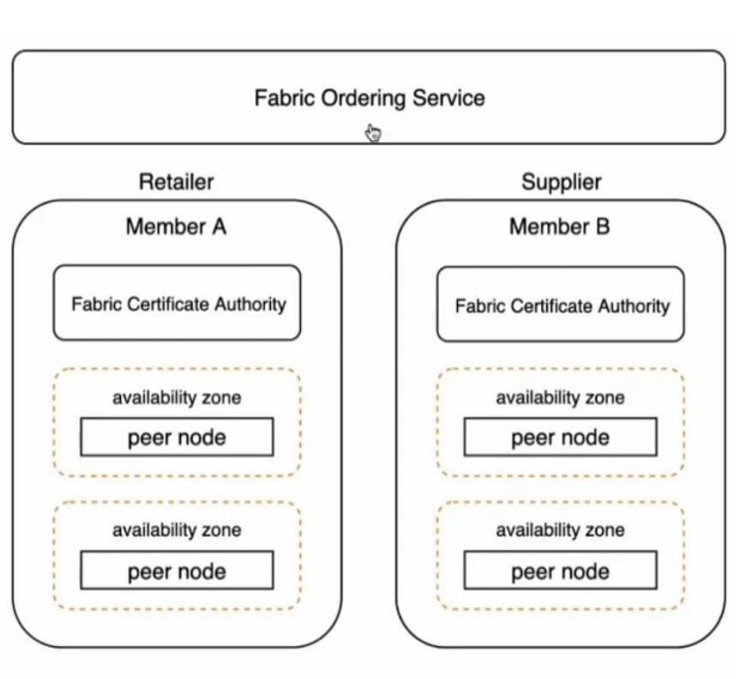
Fig 1.0 Fabric ordering service design
Fabric Certificates: Fabric certificates are cryptographic identification documents that give network users confirmation of their identities. Fabric certificates, which were generated by a reliable certificate authority, are held by both Member A and Member B.
An availability zone: is a unique data centre located within an AWS region. In this situation, Member A and Member B can converse and do business securely because they are both connected to the same availability zone.
Peer Nodes: Peer nodes are instances of the Hyperledger Fabric framework used by participants. Peer nodes put within the shared availability zone belong to each member individually.
Authentication procedure: Member A sends a request to the network upon starting a fabric order. A digital signature created with the help of the request's fabric certificate is present. The request's integrity and authenticity are guaranteed by the signature.
Verification: Request from Member A is received by the peer nodes in the availability zone. They verify that the request is coming from an authorised source by validating the digital signature using Member A's fabric certificate.
Consensus: After the request has been validated, the peer nodes agree that the transaction is valid. By doing this, the network's participating nodes are guaranteed to concur on the fabric order's current state.
The confirmed transaction is carried out after a consensus has been reached, and Member B, the supplier, is informed of the fabric order. Using Member A's fabric certificate, the peer nodes of Member B within the same availability zone verify the transaction request.
Both Member A and Member B can authenticate themselves and guarantee the integrity and security of the fabric ordering process within the AWS blockchain service by utilising fabric certificates and the availability zone with peer nodes.
The next step involves creating a cloud9 environment which is done using AWS management console selecting instance and launch environment.
Setup IAM policies and configurations are set up to establish the respective retailer and manufacturer nodes on the management console. This will provide the necessary privileges needed for our Cloud9 environment that is used to access our block chain network.
Once both parties within the supply chain are authenticated and then certain policies are met between them they can access the cloud services and connect to the blockchain network.
Each member in the consortium has their respective certificate authority that enables them in managing the identities of users who are authorised and authenticated to access the managed blockchain network, as well as the respective retailer and manufacturer peer nodes, which endorse transactions and store blockchain data. The peer nodes are situated in different availability zones to ensure high availability and for failover and disaster recovery purposes. This Infrastructure is managed by AWS and accessed by each member over a VPC endpoint using AWS private link.Members and networks can be deployed onto the system. After the network and member creation is complete after which we create a peer node for the Retailer as per the hyper fabric ledger architecture illustrated in the next slide. This is the component that validates the blockchain transactions and stores the block details in a blockchain ledger.
All interaction with the blockchain network stems from a Fabric client. This client node shall have the Fabric SDK which after being installed within it will let us generate digital certificates that represent the authenticated end users.
Network security groups are then created for the Fabric client instance. All communication between member peer nodes and Fabric client instances must occur through a VPC endpoint using AWS private link. A Cloud9 environment will be used as the Fabric Client. In order for it to communicate with the blockchain network over the VPC endpoint as illustrated in fig 1.1, it needs to be in the same security group. After the client instance is created we configure it to communicate with our managed blockchain network.
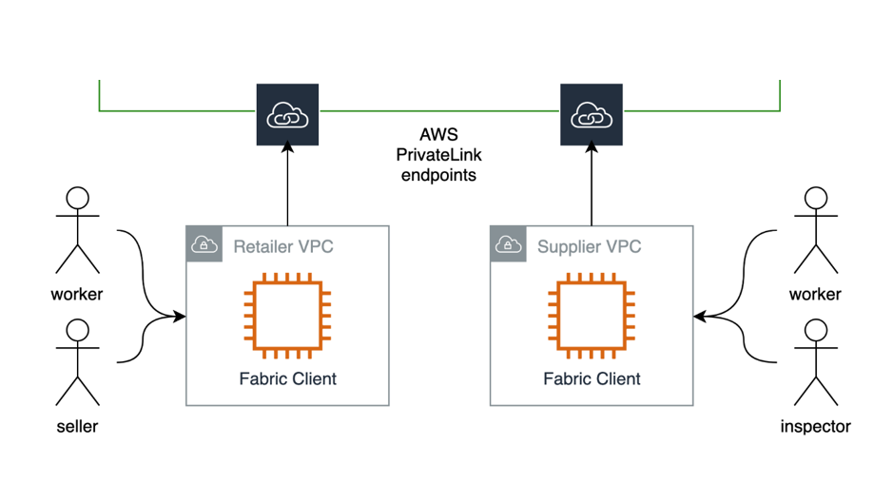
Fig 1.1 VPC endpoint architecture

  - Using a mix of blockchain technology, AWS services, and the Fabric client, members of the supply chain, such as employees and merchants, can use cloud functions in a track and trace application. The blockchain acts as a decentralised, unchangeable ledger to provide supply chain transparency and trust. Scalable infrastructure and networking capabilities are offered by Amazon Web Services (AWS) for hosting the application. Users can submit transactions and retrieve data using the Fabric client, which serves as an interface between the application and the blockchain network. Using a Virtual Private Cloud (VPC), retailers may safely link their infrastructure to the cloud environment, while AWS PrivateLink endpoints create secure connectivity between the VPCs and the necessary AWS services. Through the use of the private and secure connectivity offered by AWS PrivateLink, this configuration enables members to use the track and trace application inside of their VPCs. These elements work together to enable the application, which ensures transparency and traceability throughout the process while facilitating efficient and safe supply chain management.

  - We now deploy the chain code and create a new channel for it to execute in, have each network member join the channel, and then we deploy the chain code to the channel. The chain code is written using node.JS to accommodate its peers and serve the business logic requirements by the parties within the supply chain . It is then instantiated on the channel, at which point all members will use their different user identities to invoke the chain code, A frontend interface lets the companies register for our blockchain network with their products and their product constraints that are to be tracked in real time using the hyper ledger maintained using aws and lets members within the supply chain dynamically track their products at every location the QR code is scanned and which gets dynamically updated in the blockchain network.

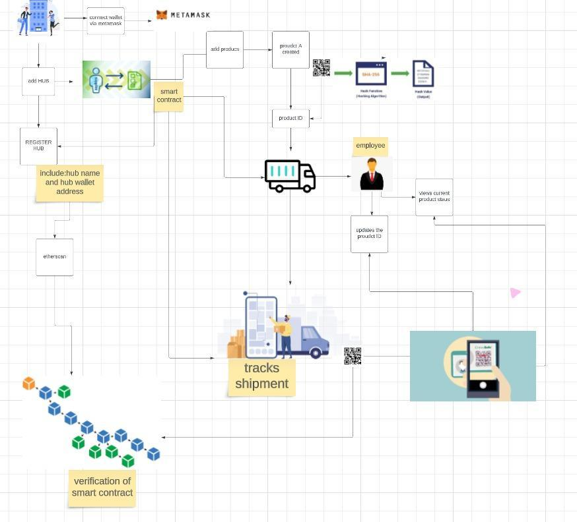
Fig 1.2 System Architecture

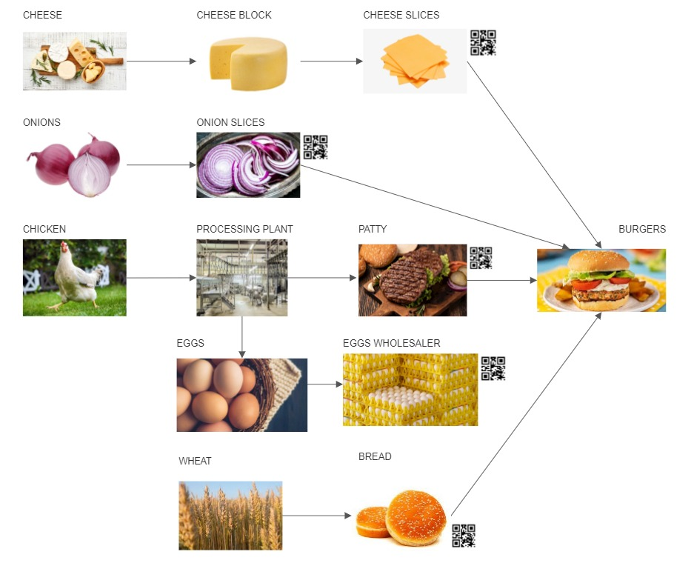
Fig 1.3 QR code tracking in a typical food supply chain
Registration:
- The contract includes functions for registering companies and hubs.
- The registerCompany function allows a company to register itself by providing a unique name.
- The registerHub function allows a registered company to register a hub under its ownership.
Product Management:
- The addProduct function enables a registered company to add a new product to the supply chain system.
- It generates a unique product ID by combining the first three characters of the company's address with the total number of products registered by the company.
- The new product is created and associated with the relevant information, including the company, name, manufacturing date, origin hub, destination hub, and initial status.
- The product is added to the company's list of products.
Tracking and Status Updates:
- The updateProductStatus function allows a hub to scan a product and update its status in the supply chain.
- The function verifies if the hub is valid, if the hub and product belong to the same company, and increments the hop count if the hub is the destination hub.
- The status update, including the timestamp and hub address, is recorded for the specific hop count of the product.
- The getCurrentStatus function enables a registered company to retrieve the current status of a product by accessing the product's history of status updates.
Information Retrieval:
- The contract includes functions to retrieve information about the registered companies, hubs, products, and their statuses.
- The getCompanyProducts function allows a registered company to retrieve a list of all the products it has registered.
- The getProdID function returns the most recent product ID added to the system.
- The isCompany and isHub functions check the existence of a company and a hub, respectively, based on the provided addresses.
The contract facilitates the registration of companies and hubs, enables the addition of products with unique IDs, tracks their status updates as they move through different hubs, and provides functions to retrieve information about the registered entities and product statuses.
As part of the integration of the QR code architecture, demonstrated in fig 1.3, each product would normally have its own unique QR code. When a QR code is scanned, a process is launched to retrieve the current state of the relevant product using the Fabric client and blockchain network. In order to retrieve the product's past status updates and offer comprehensive information about its present state, the Fabric client would communicate with the smart contract.
The solution enables safe registration, effective product administration, precise tracking and status updates, and simple retrieval of data regarding registered entities and product statuses by fusing the Fabric architecture, blockchain network, and QR code integration.

ADVANTAGES OF USING A COMBINED ARCHITECTURE
Peer Nodes Provisioning: In the proposed supply chain blockchain network, peer nodes play a crucial role in the endorsement and validation of transactions, as well as the maintenance of the blockchain ledger. Peer nodes are instances of the Hyperledger Fabric framework that are deployed within an availability zone in Amazon Web Services (AWS). The availability zone provides isolation and redundancy, ensuring high availability and fault tolerance for the network.
Each member of the consortium, such as the retailer (Member A) and the supplier (Member B), has their own set of peer nodes deployed within the shared availability zone. These peer nodes are responsible for validating and endorsing transactions specific to their respective members. When a transaction is initiated, the peer nodes verify the authenticity and integrity of the transaction by validating the digital signatures using fabric certificates. This ensures that only authorised and authenticated transactions are accepted and recorded on the blockchain.
To ensure secure communication between member peer nodes and the Fabric client instances, a Virtual Private Cloud (VPC) endpoint using AWS PrivateLink is utilised. This enables private and isolated communication channels, preventing unauthorised access to the network. The peer nodes and Fabric client instances are connected through the VPC endpoint, establishing a secure and dedicated link.
QR Code Scanning: In the supply chain application, QR codes are used to uniquely identify products and enable efficient tracking throughout the supply chain. Each product is assigned a unique QR code, which contains information about the product and its journey. When a QR code is scanned, the information embedded within it is used to retrieve the current state of the product from the blockchain network. The Fabric client, which acts as the interface between the application and the blockchain network, facilitates this process. The Fabric client utilises the scanned QR code to communicate with the smart contract deployed on the blockchain network. The smart contract contains predefined functions that enable the retrieval of product information and status updates. By interacting with the smart contract, the Fabric client retrieves real-time data about the product, including details such as manufacturing date, origin hub, destination hub, and current status. The blockchain ensures the immutability and transparency of the product's information by recording every status update and movement on the ledger. This allows stakeholders to trace the product's journey and verify its authenticity, ensuring trust and reliability throughout the supply chain.
Combining peer node provisioning and QR code scanning brings several benefits to the supply chain blockchain network:
Trust and Transparency: The blockchain technology used in the network ensures the immutability and transparency of transactions and product information. This fosters trust among participants and provides a reliable and auditable supply chain system.
Secure Communication: The establishment of secure communication channels, such as the VPC endpoint using AWS PrivateLink, ensures that data transmission between member peer nodes and Fabric client instances remains private and protected from unauthorised access. This enhances the overall security of the supply chain ecosystem.
Efficient Supply Chain Management: Peer nodes play a critical role in validating and endorsing transactions, enabling efficient supply chain management. The use of QR codes allows stakeholders to quickly and accurately track product movements, facilitating streamlined operations and timely decision-making.
Enhanced Traceability: QR code scanning provides real-time access to product information and status updates. By leveraging the blockchain network, stakeholders can trace the entire journey of a product, including its origin, manufacturing processes, transportation, and current location. This comprehensive traceability mechanism enables better quality control, compliance, and customer satisfaction.
Improved Security: The authentication mechanisms implemented through fabric certificates ensure that only authorised entities can access and interact with the blockchain network. This enhances the overall security of the supply chain ecosystem by preventing unauthorised access and tampering of data.
By combining peer node provisioning and QR code scanning, the supply chain blockchain network offers a robust and efficient solution for transparent, secure, and traceable supply chain management. It empowers stakeholders with the ability to authenticate transactions, track product movements in real-time, and access accurate and reliable information, leading to improved operational efficiency, customer satisfaction, and overall supply chain performance.

RESULTS
A decentralised track and trace application is built to service the needs of companies who require a common platform to create, customise and maintain their supply chain networks as well as track the dispatch of products from one hub within the network to the next through a blockchain ledger and unique QR codes generated for each batch. The combined architecture makes use of the different availability zones provided for the maintenance of every vpc endpoint in the aws fabric client that functions as both an information retrieval unit as well as a status update unit at each hub of the supply chain. The company side of the application can create products, register new hubs and track the progress of the shipment of their created products through updated time stamps while the worker side of the platform has functionality to scan the dispatched QR code and update status. The supply chain network can be scaled using aws functionalities to create more vpc endpoints to accommodate more hubs.

- CONCLUSION
In conclusion, blockchain distributed ledger technologies has the potential to transform supply chain management by upgrading traceability, transparency, and security. This technology is based on a decentralised, distributed ledger that lets the stakeholder access and update information in real-time that can be used to track supply chain management systems. The literature review conducted for this survey paper on implementation of blockchain in supply chain management has shown that blockchain technology has the potential to significantly improve supply chain efficiency, reduce costs, and increase trust among supply chain partners.

The literature review also highlighted several challenges and limitations as well as the applicability of implementing blockchain technology in supply chain management, such as scalability, regulatory compliance, and data privacy concerns. Therefore, it is crucial that organisations carefully evaluate the latent benefits and drawbacks of blockchain technology before a viable implementation. The literature review also revealed that blockchain adoption in SCMs is still in its initial stages, with most of the current use cases being pilot projects and proof of concepts. The most common use cases for blockchain technologies and smart contracts in supply chain management are for tracking and traceability of goods, digital identity management and smart contract automation.
The future research in this area should focus on addressing the challenges of scalability and regulatory compliance, as well as exploring the potential of blockchain technology to improve other aspects of supply chain management, such as inventory management and logistics. Additionally, more research is needed to explore the potential of blockchain technology that facilitates and improves on the productivity and sustainability of supply chains.
Overall, the specified blockchain technologies have the capacity to transform the way supply chains operate, but further research is needed to fully realise its potential and address the challenges of implementation.

References

[1] Karumanchi, Mani Deep, J. I. Sheeba, and S. Pradeep Devaneyan. "Cloud based supply chain management system using blockchain." 2019 4th International Conference on Electrical, Electronics, Communication, Computer Technologies and Optimization Techniques (ICEECCOT). IEEE, 2019.

[2] Nandi, Madhavi Latha, et al. "Blockchain technology-enabled supply chain systems and supply chain performance: a resource-based view." Supply Chain Management: An International Journal 25.6 (2020): 841-862.

[3] Tribis, Youness, Abdelali El Bouchti, and Houssine Bouayad. "Supply chain management based on blockchain: A systematic mapping study." MATEC Web of Conferences. Vol. 200. EDP Sciences, 2018.

[4] Mukherjee, Sourav. "Benefits of AWS in the modern cloud." arXiv preprint arXiv:1903.03219 (2019).

[5] Straubert, Christian, Eric Sucky, and Jens Mattke. "Blockchain technology for tracking and tracing in supply chains: A critical viewpoint." (2021).

[6] Lambert, Douglas M., and Martha C. Cooper. "Issues in supply chain management." Industrial marketing management 29.1 (2000): 65-83.

[7] Korpela, Kari, Jukka Hallikas, and Tomi Dahlberg. "Digital supply chain transformation toward blockchain integration." (2017).

[8] Azzi, Rita, Rima Kilany Chamoun, and Maria Sokhn. "The power of a blockchain-based supply chain." Computers & industrial engineering 135 (2019): 582-592.

[9] Abeyratne, Saveen A., and Radmehr P. Monfared. "Blockchain ready manufacturing supply chain using distributed ledger." International journal of research in engineering and technology 5.9 (2016): 1-10.

[10] Sternberg, Henrik S., Erik Hofmann, and Dominik Roeck. "The struggle is real: insights from a supply chain blockchain case." Journal of Business Logistics 42.1 (2021): 71-87.

[11] Clauson, Kevin A., et al. "Leveraging Blockchain Technology to Enhance Supply Chain Management in Healthcare:: An exploration of challenges and opportunities in the health supply chain." Blockchain in healthcare today (2018).

[12] Kim, Joon-Seok, and Nina Shin. "The impact of blockchain technology application on supply chain partnership and performance." Sustainability 11.21 (2019): 6181.

[13] Rogerson, Michael, and Glenn C. Parry. "Blockchain: case studies in food supply chain visibility." Supply Chain Management: An International Journal 25.5 (2020): 601-614.

[14]Helo, Petri, and A. H. M. Shamsuzzoha. "Real-time supply chain—A blockchain architecture for project deliveries." Robotics and Computer-Integrated Manufacturing 63 (2020): 101909.

[15] Kamble, Sachin, Angappa Gunasekaran, and Himanshu Arha. "Understanding the Blockchain technology adoption in supply chains-Indian context." International Journal of Production Research 57.7 (2019): 2009-2033.

[16] Perboli, Guido, Stefano Musso, and Mariangela Rosano. "Blockchain in logistics and supply chain: A lean approach for designing real-world use cases." Ieee Access 6 (2018): 62018-62028.

[17] Gonczol, Peter, et al. "Blockchain implementations and use cases for supply chains-a survey." Ieee Access 8 (2020): 11856-11871.Vu, Nam, Abhijeet Ghadge, and Michael Bourlakis. "Blockchain adoption in food supply chains: A review and implementation framework." Production Planning & Control (2021): 1-18.

[18] Vu, Nam, Abhijeet Ghadge, and Michael Bourlakis. "Blockchain adoption in food supply chains: A review and implementation framework." Production Planning & Control (2021): 1-18.

[19] Baruffaldi, Giulia, and Henrik Sternberg. "Chains in chains-logic and challenges of blockchains in supply chains." (2018).

[20] Agrawal, Tarun Kumar, et al. "Blockchain-based framework for supply chain traceability: A case example of textile and clothing industry." Computers & industrial engineering 154 (2021): 107130.

